For Sale 1981 Piper Turbo Arrow IV $150,000 USD

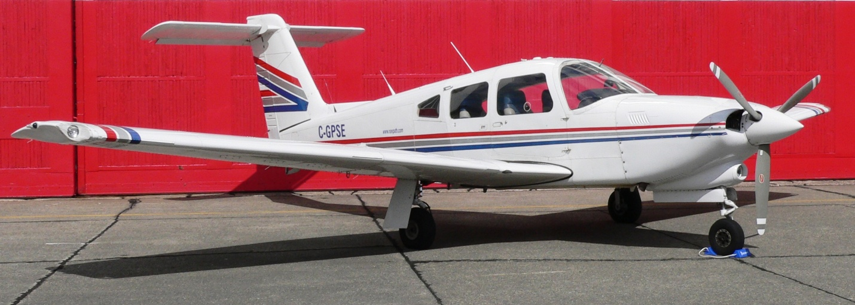

PA-28RT-201T 28R-8131079 C-GPSE

Airframe
3,350 hours total time Useful load: 994 pounds
Annual Inspection completed on June 1, 2026

Engine
200 HP Teledyne Continental TSIO-360-FB (15)
Factory Remanufactured TSOH 1500 hours
Turbo GAMIjector Fuel Injectors
Pressurized magnetos
Merlyn Products Inc. Automatic Wastegate turbocharger differential pressure controller
Aero Safe – Electrically driven standby vacuum pump
Bogert Aviation copper electrical cables
Brackett Aero Filters air filter
Piper auxiliary power cables

Propeller
3 Blade Hartzell – Overhauled May 2, 2022, at 3,256 hours

Interior
New Leather seats & carpet installed June 15, 2004
at 2,275 hours total time

Exterior
Original factory paint

No known damage history – Complete logs available
RMD Aircraft Lighting Wing Tips with Strobes and Landing lights
Precise Flight PulseLight System
Scott Executive III Oxygen System with two cannulas
Overhead ventilation blower
Kennon Cowl Plugs and Sun Shields for all windows
Fuselage and wing interior factory corrosion treated with zinc chromate
Avionics
Garmin GNS 530W GPS/NAV/COM #1 displays on the
Bendix / King KCS-55A Compass System KI-525A HSI
Garmin GNS 430W GPS/NAV/COM #2 displays on the Garmin GIA 106A Nav Indicator
Garmin GMA 340 Audio Panel
Garmin GTX 327 Transponder
S-TEC Autopilot System 40 interfaced with GNS 530W and King KI-525A HSI
S-TEC ST-901 GPSS Roll Steering Converter interfaced with S-TEC System 40 and GNS 530W
S-TEC Autopilot System 60 PSS interfaced with the King KI-525A HSI and GNS 530W
S-TEC Automatic Electric Pitch Trim
L3 Stormscope WX-500 displays on the GNS 530W and the GNS 430W
J.P. Instruments EDM-700 engine monitor
J.P. Instruments FlowScan fuel flow sensor interfaced with the J.P.I. EDM-700 and the Garmin GNS 530W
Horizon Instruments P1000 Digital Electronic Tachometer
ACK Technologies E-04 406 ELT, Avionics master switch
Electronics International E-1 Primary EGT
Astro Tech LC-2P Electronic Clock

Features
Many modifications and STCs, all fully documented.
For the last 20 years this aircraft has been owned and flown by a Professional Pilot, Class 1 Flight Instructor, Pilot Examiner and former Transport Canada Inspector.
Training / checkout available for the new owner.
Based at Langley, British Columbia (CYNJ)

Export Certificate of Airworthiness available locally

